***Blind spot for 2 wheelers***

* What is BS

Blind spot is the visual region which cannot be seen due to a defect in the retina, in this context, The Region where we cannot see anything while driving a vehicle ahead of using all the mirrors and cameras associated with the vehicle. Blind spot is an area around your vehicle that the driver cannot observe through the use of their mirrors or cameras, without turning their head, therefore taking their eyes off the road. Nearly all vehicles have at least one blind spot. Which leads to ignorance of the other objects as well as vehicle and results in an accidental mishap.

* Types

Blind spots are usually everywhere around the vehicle. Location of the blind spot varies by the type of the vehicle hence the classification is done on the same basis. Also, the location of the spot is taken into consideration.

1. **HEAVY VEHICLE**

In Front: Longer the hood/bonnet of the vehicle creates a BS. Sometimes it can fit a hatch in this spot

On the sides: rear-view mirrors of the HV are limited compared to huge size, creates a large area as BS

At Rear: non-operational inside rear view mirror due to carriage van.

1. **Light Motor Vehicle**

**In Front:** just ahead of the hood, can be considered as unharming BS

**On the sides:** just side of the trunk due to mirror placement

**On the Back:** Near to rear side of the vehicle

1. Motor Cycles:

In Front: N/A

On the Sides: side of the pillion and beyond.

On the Back: near to the rear side of the vehicle

* Why

**TALLER THE VEHICLE BIGGER THE BLIND SPOTS.** Due to presence of the B-Pillars and C-Pillars in case of SUV/MUVs the driver’s vision region gets minimized and that region is termed as Blind Spot. Also, in most cases the rear-view mirrors are adjusted in a certain way leading to creation of blind spot with respect to driver. The minimalization of mirrors and cameras to reduce costs in this modern era where Safety is one of the ignored aspects while selecting a vehicle.

Sometimes it is possible if the vehicle is small but there is presence of BS. Especially in vehicles like Mopeds, Bikes, etc. These Spot are formed due to small size of mirrors as well as the differing angle of the same. On the Highways or heavy traffic roads where the speed needle is generally at high levels, with respect to the power of each individual vehicle. As the variety of vehicles roam around the highways. There is a huge difference between the relative speeds of the vehicles and so results in wide range of speeds of the vehicle. Basically, two wheelers are designed to commute in a local manner, so most of the two wheelers are designed as they cannot pass the 80kmph mark, on the other side, LMVs, Heavy Vehicles maintain the speed as low as 80 kmph and maximum 120 kmph. On the Most Highways due to this gap many accidents happen due to the negligence of attention to these kinds of blind spots.

It is necessary to alert the riders about the BSs. The main Aim of designing and implementing this kind of system to focus on this unattended problem.

* Identification of Blind Spot

the number of accidents involving motorized vehicles is increasing especially the side collision of the vehicles when the driver attempt to change from one lane to another either to left or right which is due to the carelessness of the driver and unsighted the blind spot. However, the cooperation of technology can overcome this problem. The key element is the ability to detect the incoming vehicle in the blind spot area. However, problems rises when the sensor used for the system only able to cover certain amount of area. The objectives of this study is to develop and implement a device that will warn the driver about the incoming vehicles in the blind spot area by blinking LED and to investigate the effectiveness of the system in terms of the position of the sensor used for the system. The developed system are equipped with an Arduino UNO microcontroller and ultrasonic sensor

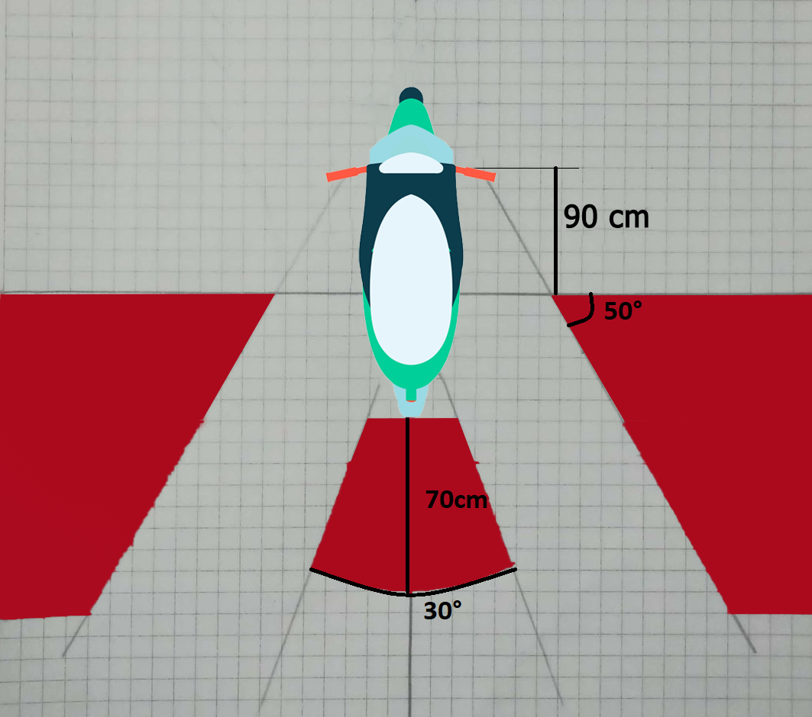

|  |  |
| --- | --- |
| Length | Width |
| 185 | 70.7 |

To implement this system on certain vehicles it is necessary to first identify the location of blind spots. To surpass this aspect, we had a practical test to know these angles and distance parameters. The vehicle used was Honda Activa 2014, of which dimensions are mentioned above. It is strongly believed that it will apply to all of the two wheelers and bikes which fits in the above-mentioned range.

Analysis of data through RTO blind spot depends on

1. Age
2. Height
3. Gender
4. Vehicle geometry /size
5. Mirror Position

Formula Ultrasonic sensor distance = (high pulse time) *velocity of sound(340m/s)

Circuit Diagram -:

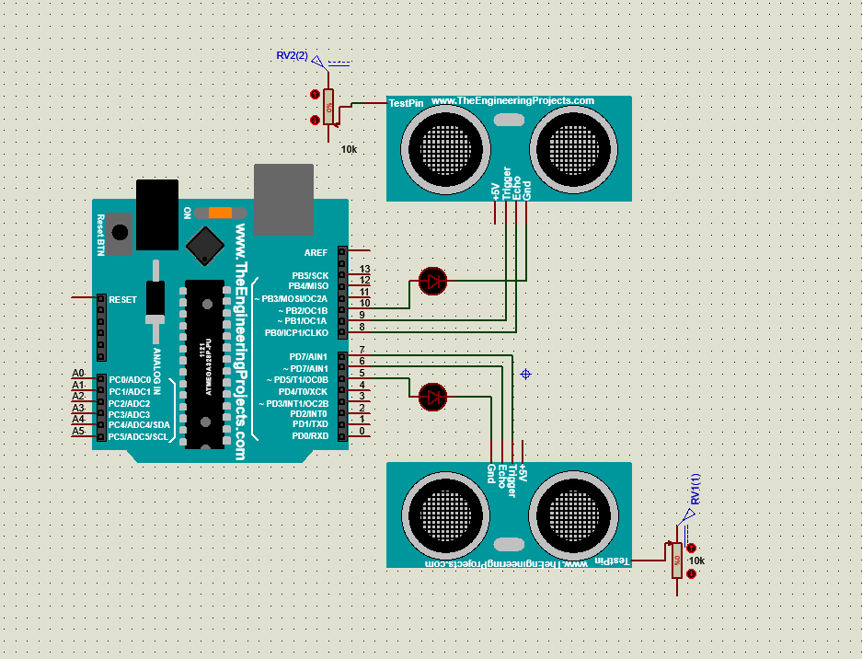

1. Arduino UNO R3

Arduino UNO R3 is the microcontroller based on ATmega328, manufactured by Arduino based in USA. It is among the best boards to encode and decode with most of the programs to create best of the mechatronics. It has 14 Digital I/O, 6 Analog Inputs, a 16Mhz ceramic resonator, a Micro USB Type-B and a Power Jack with a reset button. It is very easy to use as it gives full freedom to simply connect with a USB to a computer. We can also use it by powering it up with an AC-DC adapter as well as a DC battery to get it on the go.

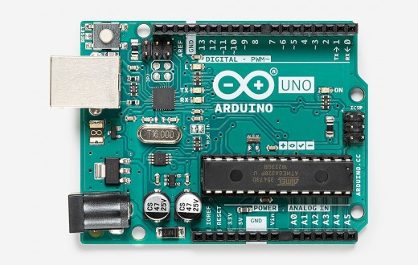

|  |  |
| --- | --- |
| Operating Voltage | 5V |
| Input Voltage | 7-12V |
| Digital I/Os | 14 (including 6 PWM pins) |
| Analog input Pins | 6 |
| DC Current per I/O Pin | 20 mA |
| Flash Memory | 32 kB (including 0.5Kb allocated for bootloader |
| SRAM | 2 kB |
| EEPROM | 1 kB |
| Clock Speed | 16 MHz |
| Length | 68.6 mm |
| Width | 53.4 mm |
| Weight |  |

1. Ultrasonic Sensor HC-SR04

HC-SR04 is a 4-pin module consists of Vcc, Trigger, Echo, and GND respectively. It has one transmitter and receiver which transmits and measures the reflecting Ultrasound. On that working principle i.e. Distance = Speed x Time it gives the distance value to the serial monitor in the Arduino. It is a eye like structure which is compact and easy design which makes it very reliable.

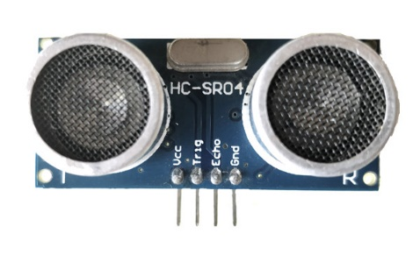 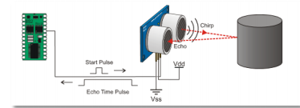

|  |  |
| --- | --- |
| Operating Voltage | 5V |
| Measuring Distance | 2 cm – 80 cm |
| Accuracy | 3 mm |
| Measuring Angle | 15**°** |
| Operating Current | 15 mA |
| Operating Frequency | 40 Hz |
| Length | 45 mm |
| Width | 20 mm |
| Height | 1. m |

3.LEDs (Light Emitting Diode)

We have used two LEDs to indicate the user whether there is a vehicle in a blind of or not. If there is an obstacle which is very close then LED will turn RED. If there is an obstacle but it is not too close then it will be Yellow. And if there is nothing in the BS it will be turned OFF or will turn Green in some special case.

* Use Case

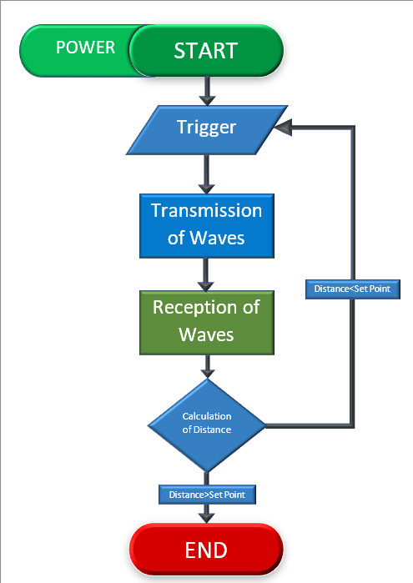

* Accuracy of sensor e.g. sensor is Applicable within 0 to 80 km/hr for the speeds above 80kmph this system is of no use.
* Distance from Sensor = HIGH-pulse Time X Velocity of Sound
* Formula Ultrasonic sensor distance = (high pulse time) *velocity of sound(340m/s)
* Accuracy Rate

|  |  |  |  |  |  |
| --- | --- | --- | --- | --- | --- |
|  | 0-20 | 20-40 | 40-60 | 60-80 | 80+ |
| Ideal |  | | |  |  |
|  |
| Summer/Winter |  |
|  |
| Rain |  |  |  | | |  |
|  |

*shaded area is termed as N/A

* References

1. <https://saaq.gouv.qc.ca/en/road-safety>
2. <https://www.vectorstock.com/royalty-free-vectors?gclid=CjwKCAjwoc_8BRAcEiwAzJevtT59jNQEyHxj09xn65s00aeYXsyJuMOufhoL1sR65DYlsK7xH4voeBoCktUQAvD_BwE>
3. <https://www.adobe.com/in/products/photoshop.html?gclid=CjwKCAjwoc_8BRAcEiwAzJevtaFB9eDwaE3cgSFtziDIqRlLrrylvNctf4Sd4NOqcLY-bUA9dnfwqxoCsdgQAvD_BwE&sdid=SGDJMMG3&mv=search&ef_id=CjwKCAjwoc_8BRAcEiwAzJevtaFB9eDwaE3cgSFtziDIqRlLrrylvNctf4Sd4NOqcLY-bUA9dnfwqxoCsdgQAvD_BwE:G:s&s_kwcid=AL!3085!3!444587836691!e!!g!!adobe%20photoshop!221441588!17534749028>
4. <https://www.honda2wheelersindia.com/BookNow?utm_source=google_search&utm_medium=text&utm_adunit=Text_ad&utm_campaign=sok_search_brand+product_activa_all&utm_adgroup=search_activa_basic_exact&gclid=CjwKCAjwoc_8BRAcEiwAzJevteKyPLzwJYuQJfBV-SGJ0tSgt1DxhsncDJwjccPG2YBx5k1eL2vp6hoC8dMQAvD_BwE>
5. <https://www.bikedekho.com/>
6. <https://www.labcenter.com/>
7. <https://fritzing.org/>
8. <https://www.autodesk.in/products/fusion-360/overview>
9. <https://www.3ds.com/products-services/catia/>
10. <https://www.arduino.cc/>
11. Microsoft Excel 2019
12. Microsoft Word 2019
13. <https://store.arduino.cc/usa/arduino-uno-rev3>
14. <https://components101.com/ultrasonic-sensor-working-pinout-datasheet>
15. Haptic Blind Spot Alert System Christopher Nebolsky, Mechanical Engineering Student, University of South Florida